

FoodBox



*(*

*Application Screenshot’s*

*)*

**A FULL STACK DEVELOPMENT**

**CAPSTONE PROJECT**

• **Version History:**

|  |  |  |
| --- | --- | --- |
| 1. | **Author Name** | Keerthana Bandari. |
| 2. | **Purpose** | Screenshots of Application. |
| 3. | **Date** | 14-06-2022. |
| 4. | **Version** | 1.0 |
| 5. | **Contact** | Keerthanabandari9184@gmail.com |

Contents.

# Project Outputs……………………………………….3

***1. Project Outputs.***

A.

Home Page.

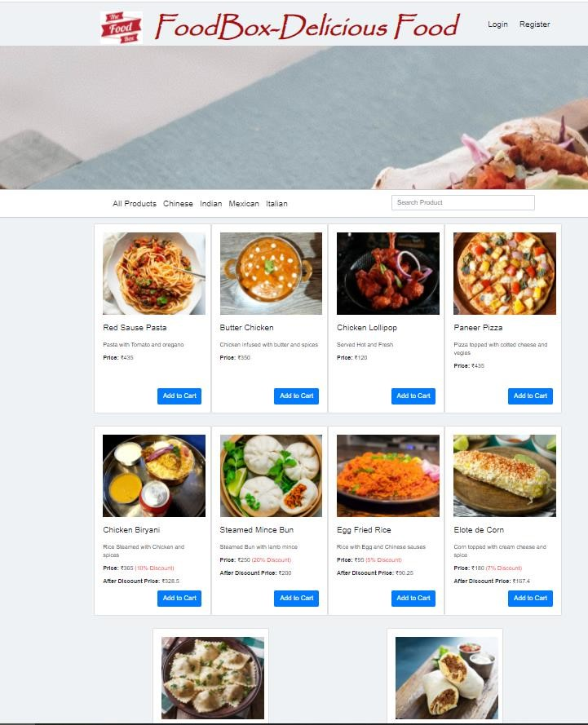

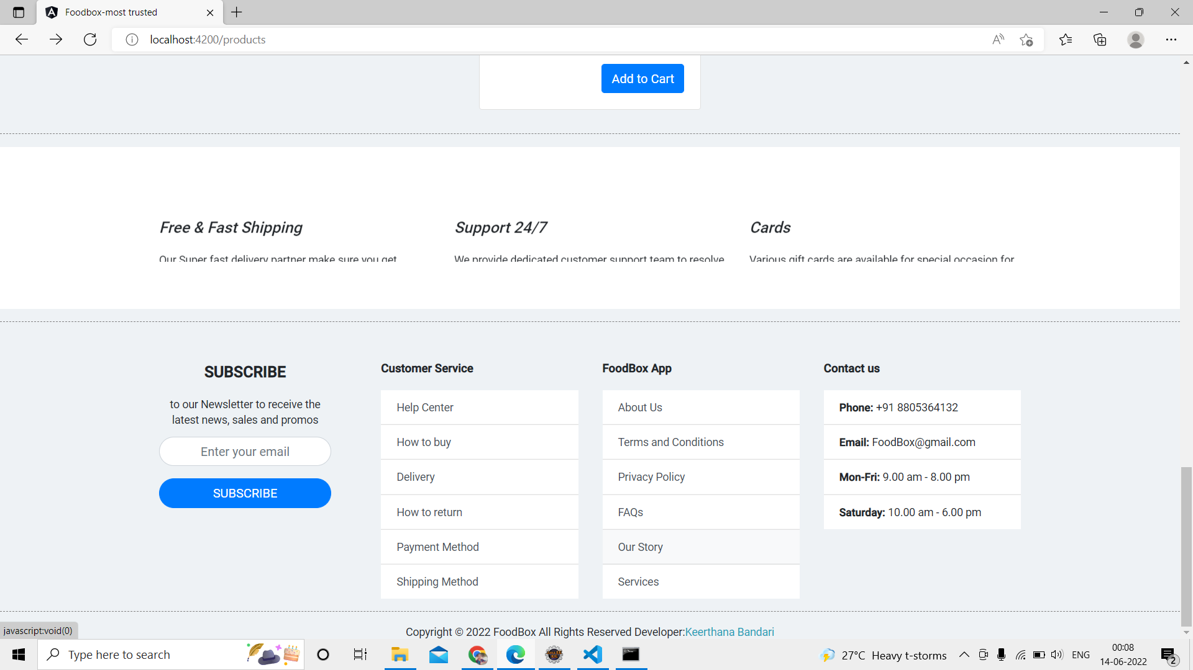

1. Login and Registration Page.

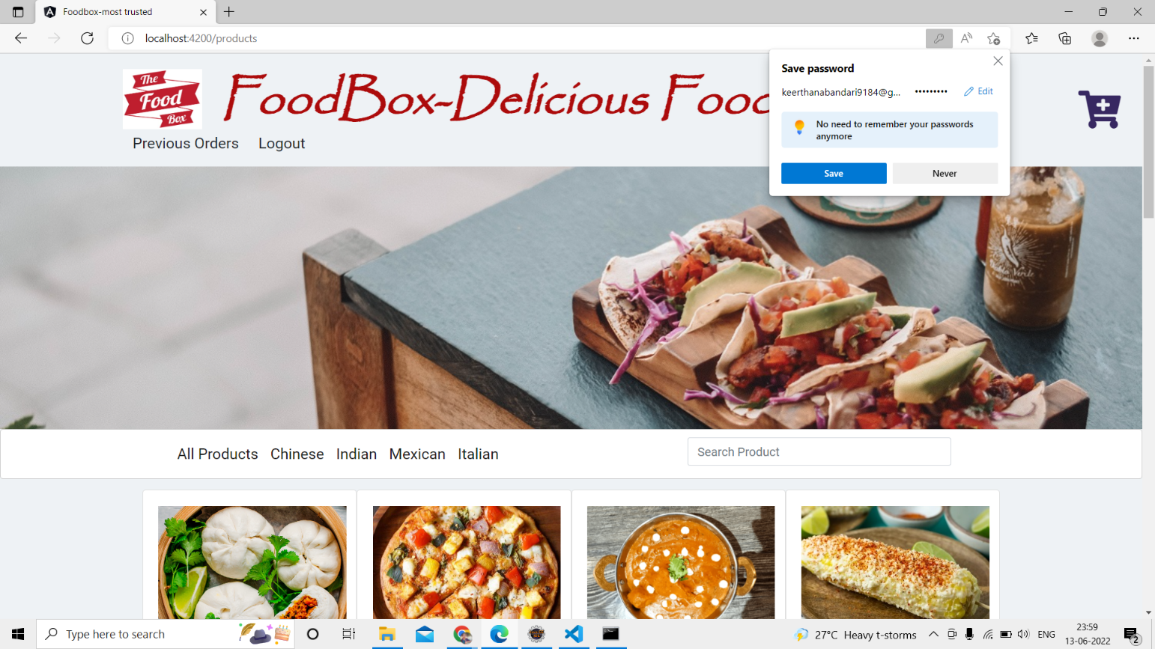

1. Admin Login Page.

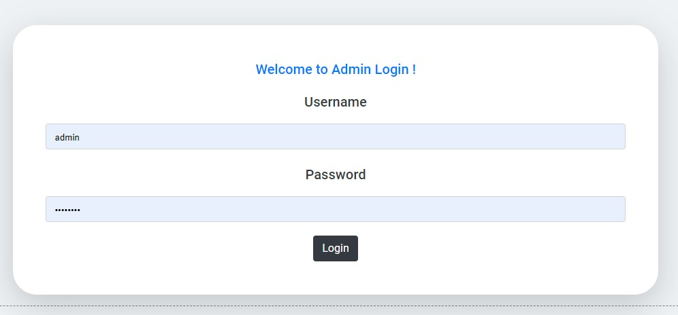

1. Manage Users , Products , Purchases.

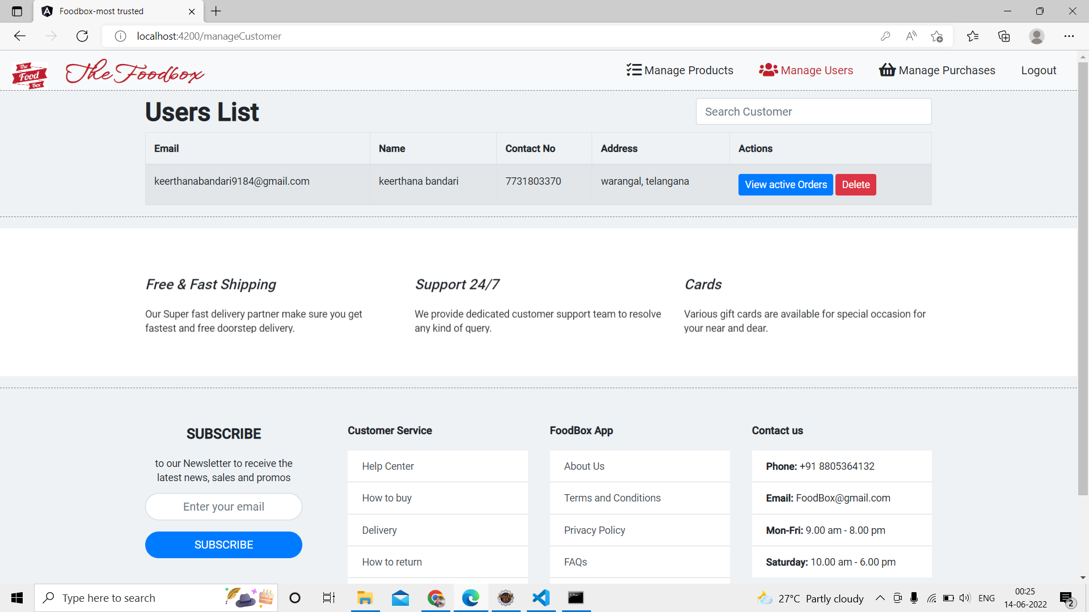

Searching and Sorting:

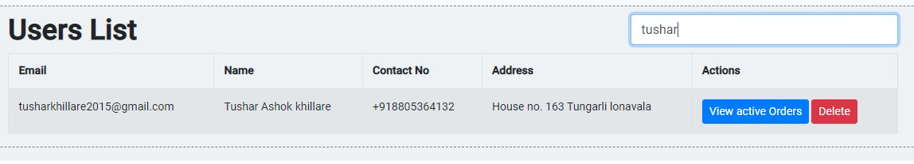

Manage Products:

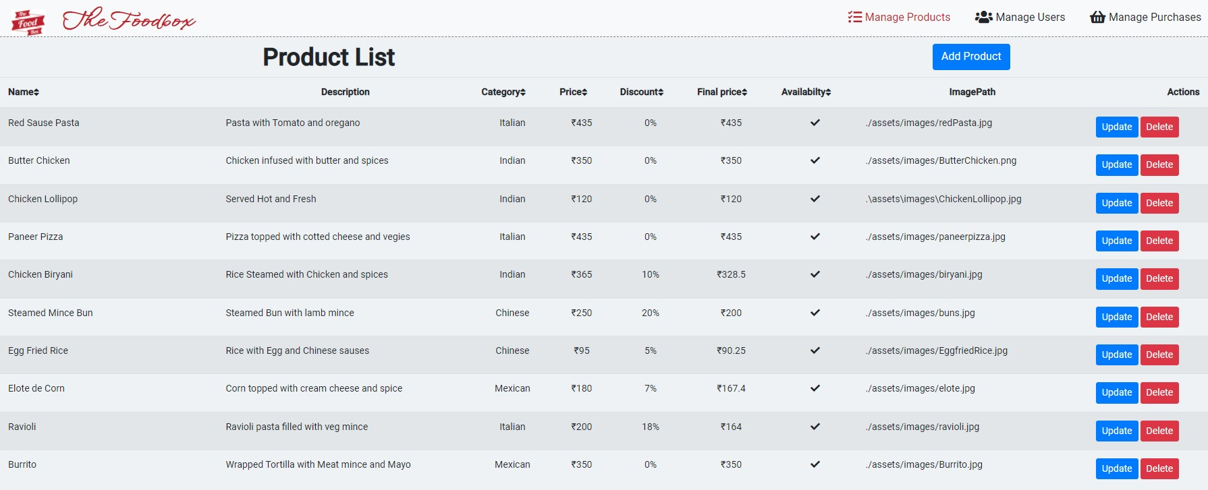

Add Product:

Update

Product:

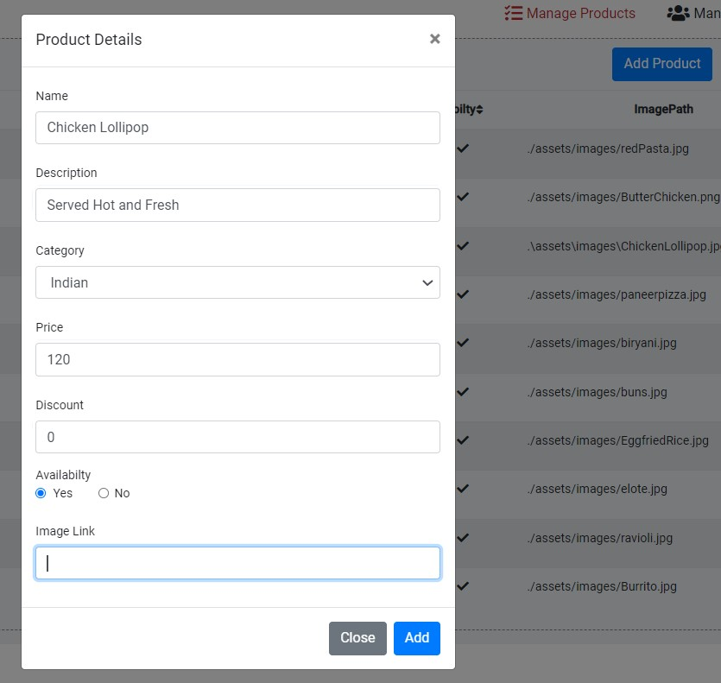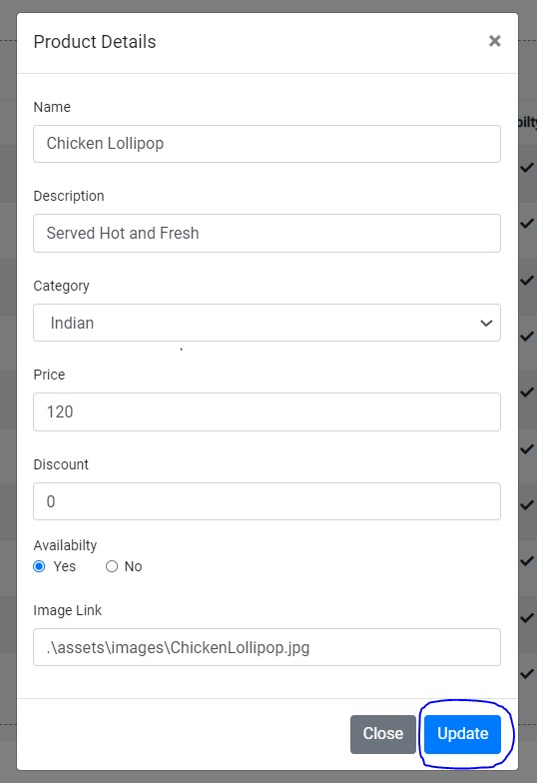

Delete Product:



Product deleted successfully…..

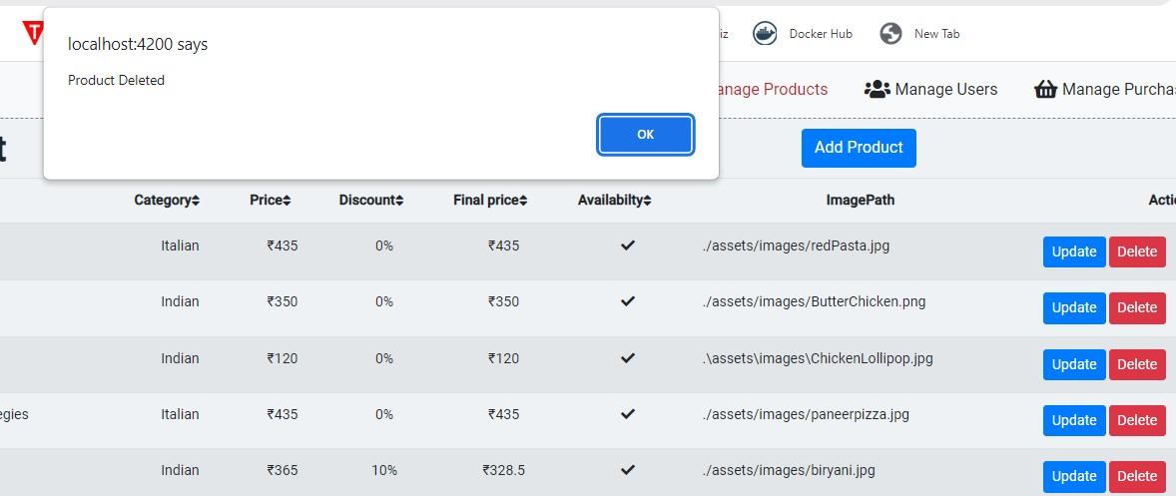

Manage Purchases:

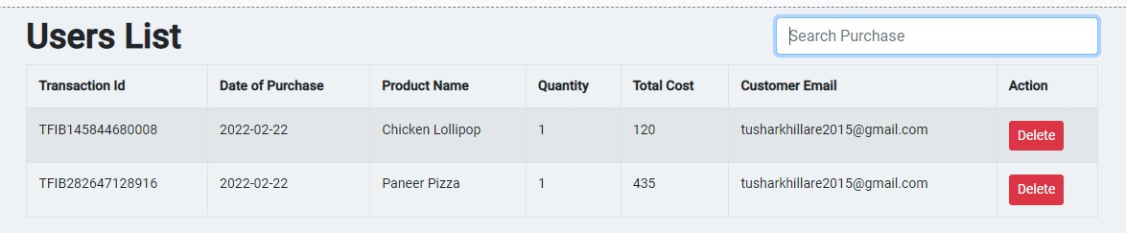

1. View Previous Active Orders.

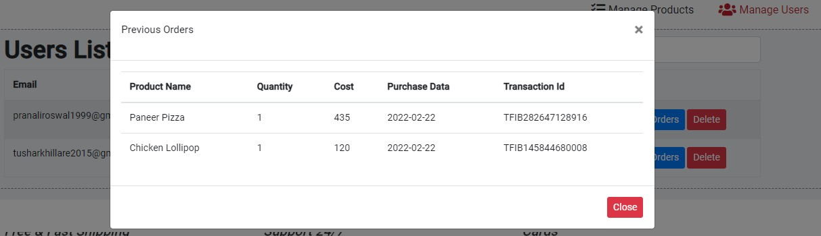

1. User Login.

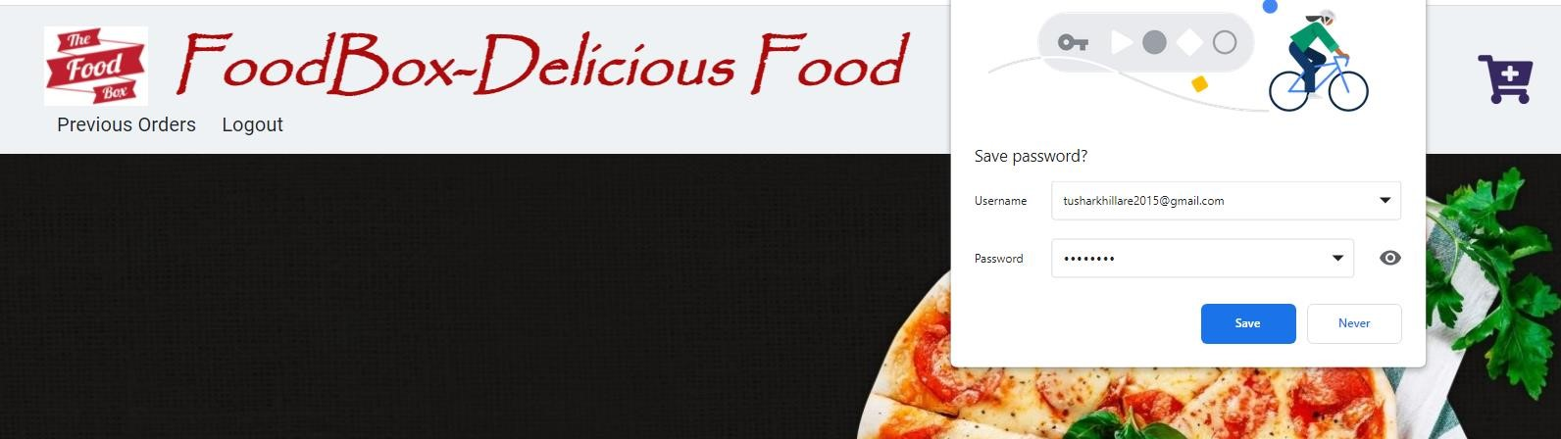

1. Add Cart / View Cart.

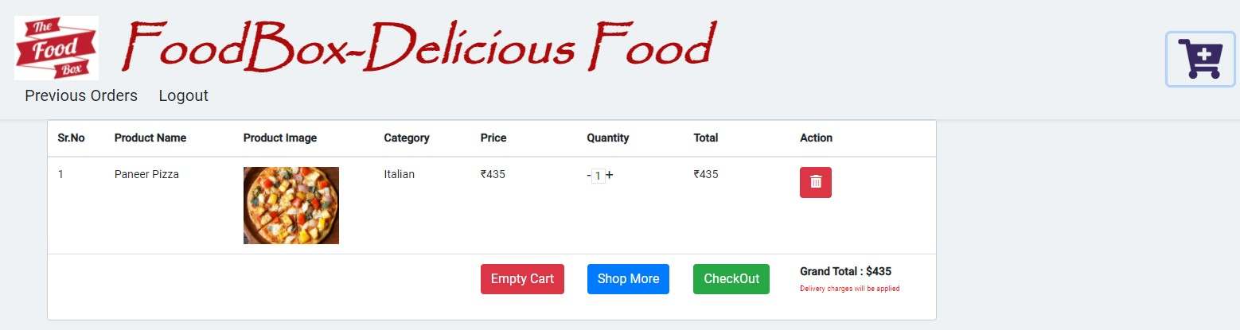

My Cart:

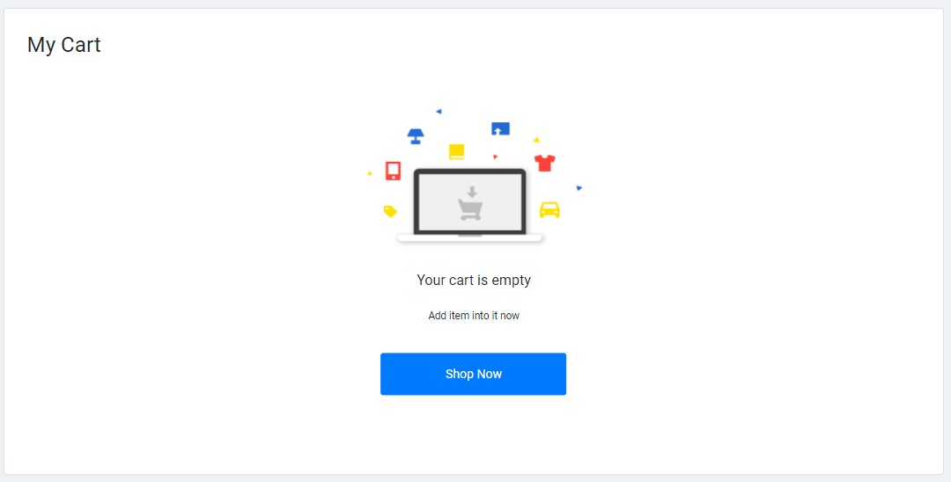

1. Payment Gateway Page.

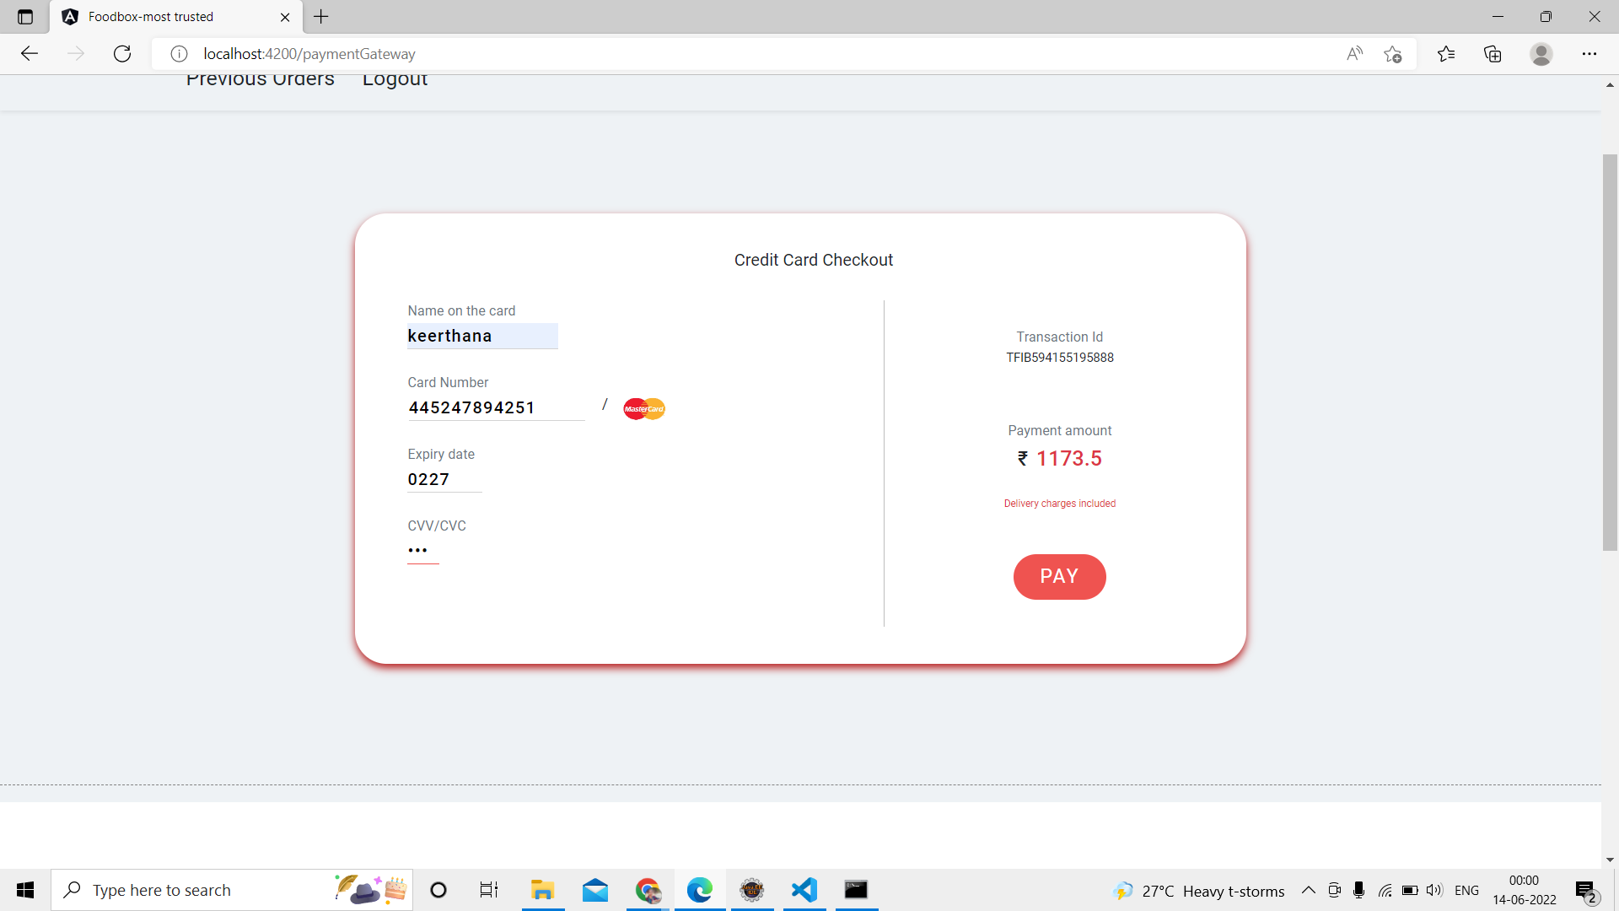

Payment Status:

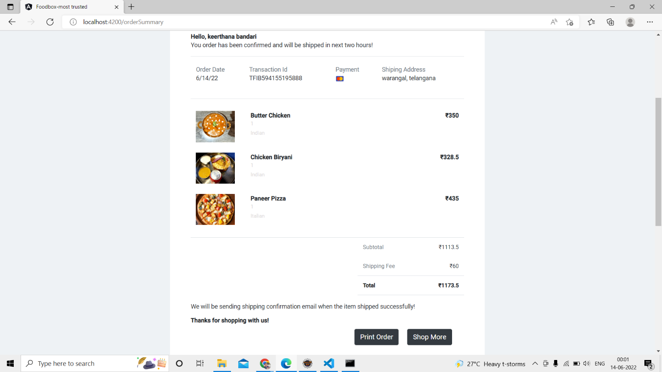

**TESTING AND DEVOPS USING JENKINS**

*Jenkins Build triggered successfully:*

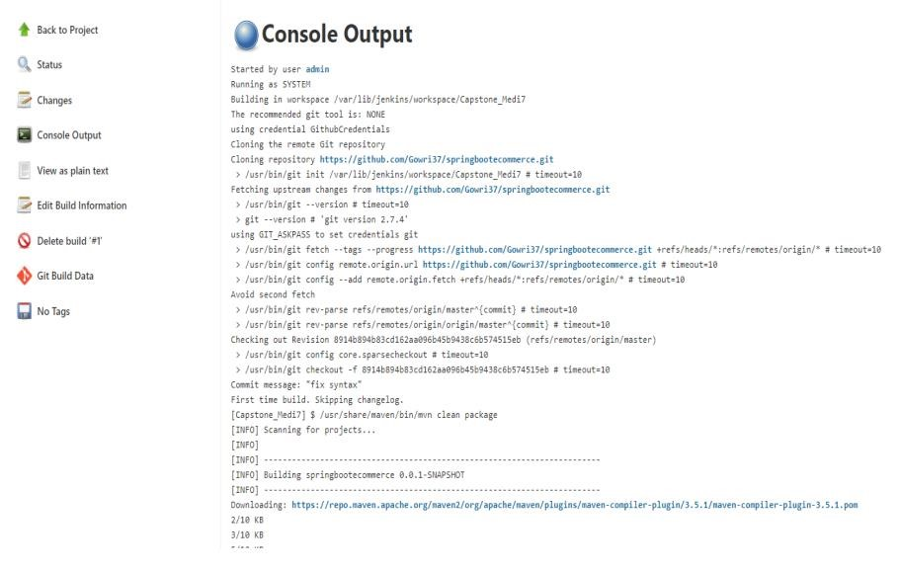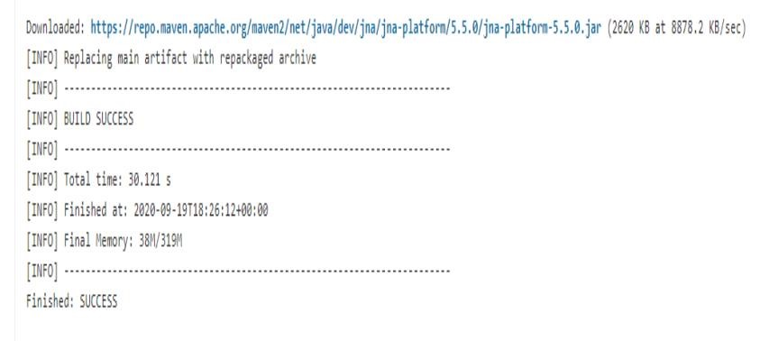

**PROJECT SCREENS POST TESTING AND JENKINS DEPLOYMENT**:

Category Based Searching

http://localhost:4200/products

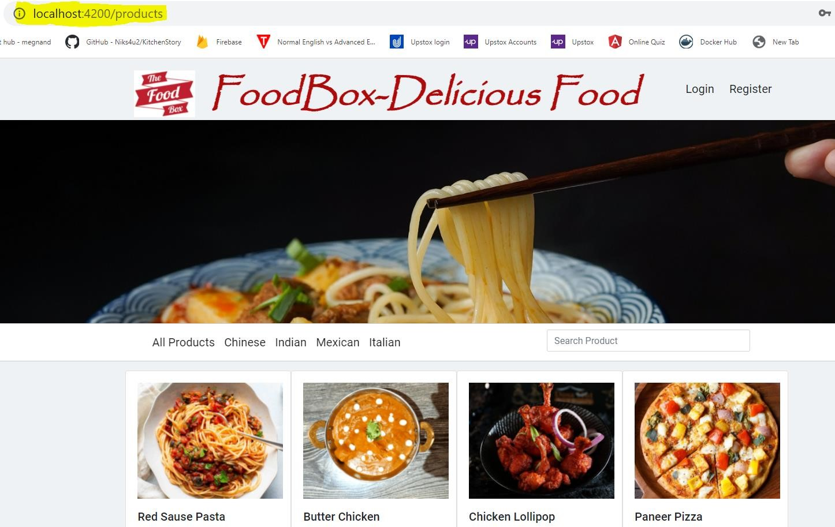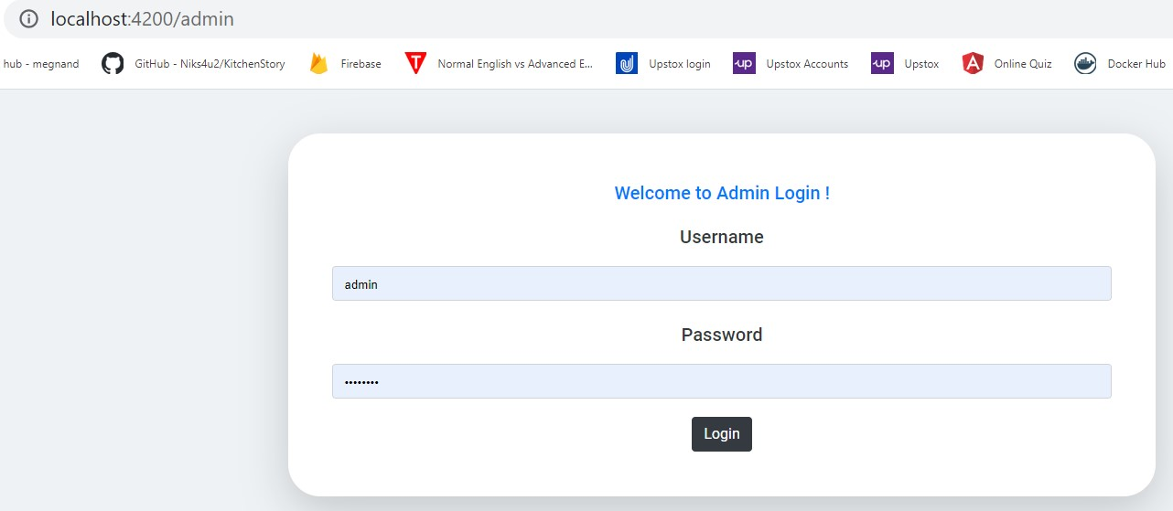

## Thank You……………